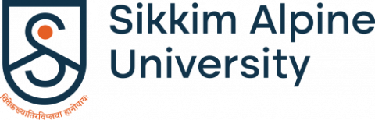

One-Day Sensitization/Awareness Program on Anti-Ragging
Organized by: Anti-Ragging Cell, Sikkim Alpine University
Date: 29th July 2024
Venue: Sikkim Alpine University, Namchi, 737126

On 29th July 2024, the Anti-Ragging Cell of Sikkim Alpine University organized a One-Day Sensitization and Awareness Program on both campuses (Kamrang and Sunakhari). The program aimed to educate students about the serious consequences of ragging and promote a safe and welcoming environment on campus. The event was part of the university's ongoing efforts to prevent ragging and ensure the safety and well-being of all students.
The objectives of the program were to raise awareness about the adverse effects of ragging, inform students about the legal consequences of engaging in such activities, foster a supportive environment where students feel safe and respected, and educate them on the available mechanisms for reporting ragging incidents.

Activities Conducted
Banner and Poster Campaign: As part of the awareness drive, banners and posters were strategically placed around the campus, including at the entrance, in classrooms, and in common areas. These materials highlighted the severe consequences of ragging, both for the culprits and the victims, and provided information on how to report any incidents.
Awareness Sessions: Throughout the day, brief awareness sessions were conducted by members of the Anti-Ragging Cell. These sessions took place in various departments, where faculty members and students gathered to discuss the importance of maintaining a ragging-free environment.
Interactive Discussions: Students were encouraged to participate in interactive discussions where they could ask questions and express their concerns regarding ragging. These discussions helped to clarify doubts and provided a platform for students to voice their opinions.

The Anti-Ragging Cell of Sikkim Alpine University successfully conducted the One-Day Sensitization and Awareness Program on Anti-Ragging on 29th July 2024. Through banners, posters, and interactive sessions, the event played a crucial role in educating the university about the dangers of ragging and promoting a safe environment on campus.
The Anti-Ragging Cell will continue its efforts to raise awareness and prevent ragging, ensuring that Sikkim Alpine University remains a safe and welcoming place for all students.

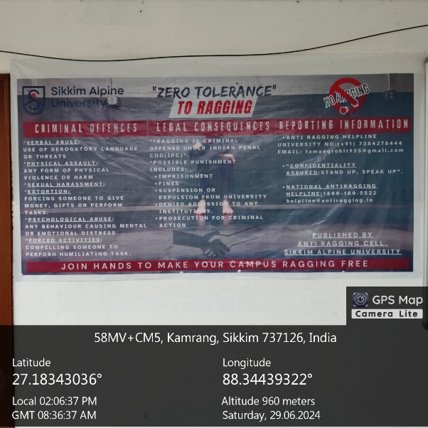

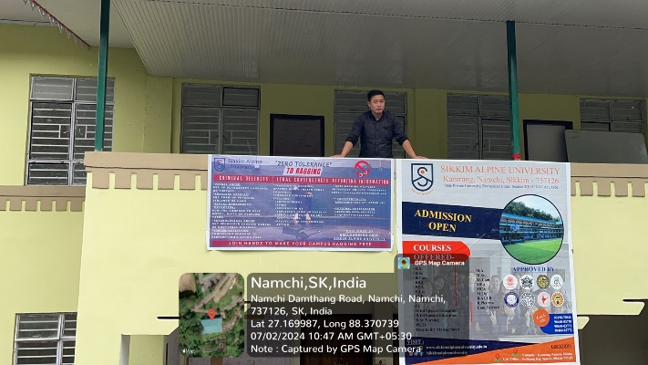

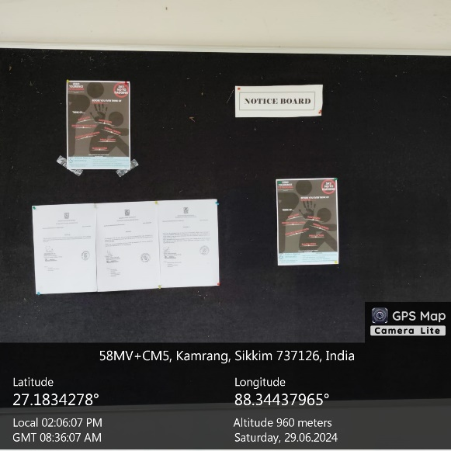
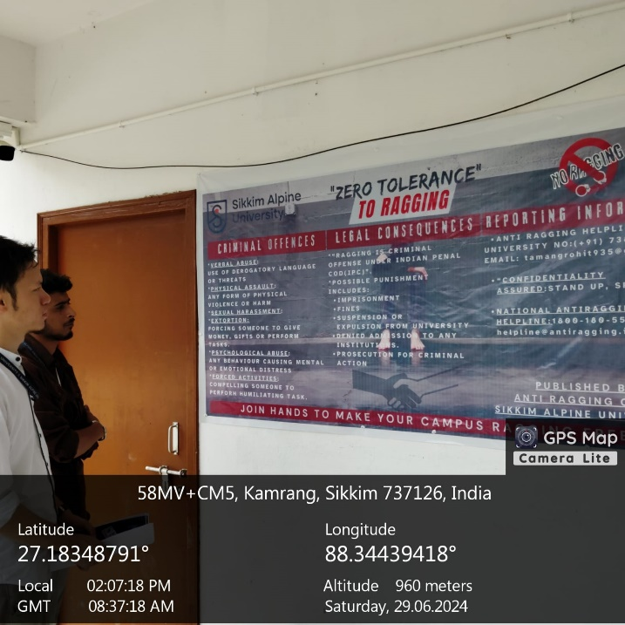

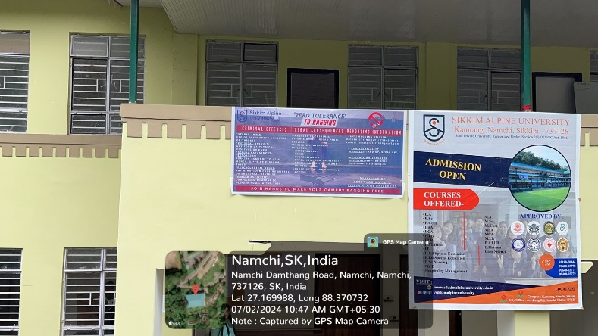

Report on Anti-Ragging Week Celebration
Organized by: Anti-Ragging Cell, Sikkim Alpine University
Date: 12th to 18th August July 2024
Venue: Sikkim Alpine University, Namchi, 737126

Sikkim Alpine University observed Anti-Ragging Week from 12th to 18th August 2024, demonstrating its commitment to creating a safe and inclusive campus environment. The week featured various activities aimed at raising awareness about the dangers of ragging and promoting a culture of respect and safety among students. A key highlight of the celebration was the creation of a UGC-compliant "Shelfie Stand," along with active student participation in producing content for Instagram Threads and posts as part of the anti-ragging campaign.

Activities Conducted

1. Shelfie Stand Design
As per the guidelines provided by the University Grants Commission (UGC), a "Shelfie Stand" was designed and set up on campus. The stand served as a focal point for students to take photographs with anti-ragging messages and slogans. The design was carefully crafted to be both visually appealing and informative, attracting students to engage with the anti-ragging campaign. The Shelfie Stand became a popular spot for students to express their support for a ragging-free campus and share their photos on social media, amplifying the message beyond the university.

2. Instagram Threads and Posts
Throughout the week, students actively participated in creating and sharing content on Instagram, using Threads and posts to spread awareness about the anti-ragging campaign. The students collaborated to produce impactful messages, that highlighted the university's anti-ragging policies, the consequences of ragging, and the importance of standing up against such practices.

3. Interactive Sessions and Discussions
Alongside the creative activities, the university hosted interactive sessions and discussions focused on the issue of ragging. These were led by faculty members, senior students, and representatives from the Anti-Ragging Cell, who shared valuable insights into the psychological and legal aspects of ragging. Students were invited to ask questions, share their perspectives, and explore ways to contribute to a ragging-free campus. These sessions facilitated open dialogue and underscored the university's dedication to student safety and well-being.

The Anti-Ragging Week celebration was highly successful, drawing enthusiastic participation from both students and staff. The Shelfie Stand and social media campaign effectively captured the students' attention, generating significant interest in the importance of preventing ragging. These activities not only heightened awareness but also empowered students to actively contribute to a safe and respectful campus environment. The digital outreach through Instagram Threads and posts further extended the anti-ragging message to a broad audience, reaching both within and beyond the university community.

