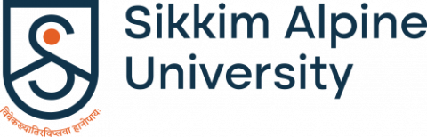

Campus Visit by Anti-Ragging Squad
Organized by: Anti-Ragging Cell, Sikkim Alpine University
Date: 5th July 2025
Venue: Sikkim Alpine University, Kamrang, Namchi, 737126

The visit was conducted on 5th July 2025 by the Anti-Ragging Squad under the Anti-Ragging Committee with the primary objective of monitoring student behaviour and ensuring strict adherence to the university’s Anti-Ragging Policies. The inspection covered various areas within the university premises, including classrooms, canteen, and the university playground.
The Anti-Ragging Squad comprised members from the teaching staff. The inspection was supervised by the Coordinator of the Anti-Ragging Cell, Mr. Rohit Tamag, along with the squad members.
Areas Inspected:
- Classrooms:
Each class from various departments was visited to observe the general conduct and interaction among students. Emphasis was laid on identifying any signs of harassment, bullying, or other behaviour indicative of ragging.
- Canteen:
The squad made a surprise inspection of the university canteen. Student groups were addressed and reminded about the consequences of ragging. No suspicious behaviour or misconduct was observed.
- Playground & Outdoor Areas:
The university playground and surrounding open spaces were also inspected. Students engaged in sports and recreational activities were found to be friendly and respectful towards peers.

The overall conduct of the students was found to be disciplined and in line with the university’s code of conduct. No instances or reports of ragging were observed or brought to the squad’s attention during the visit. Students were cooperative and aware of the anti-ragging norms. Displayed posters and awareness material on anti-ragging were found intact and visible in all major areas.

Visual Documentation:
Photographs were taken during the inspection for documentation and amplification purposes, which include squad members inspecting different classrooms, canteens and campus playground and outdoor areas.

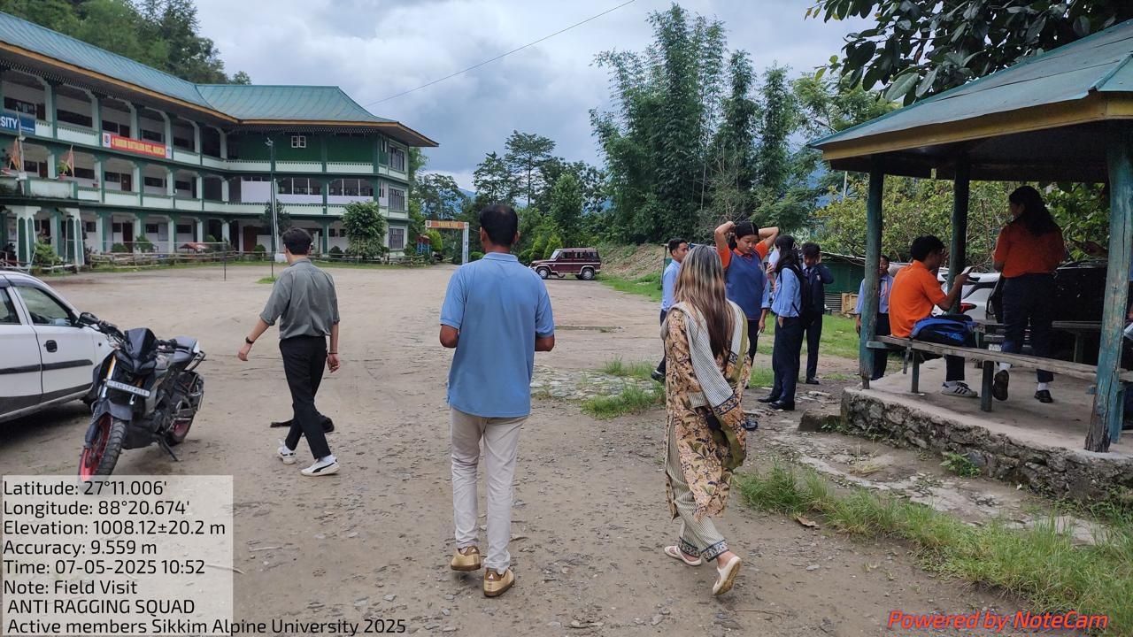

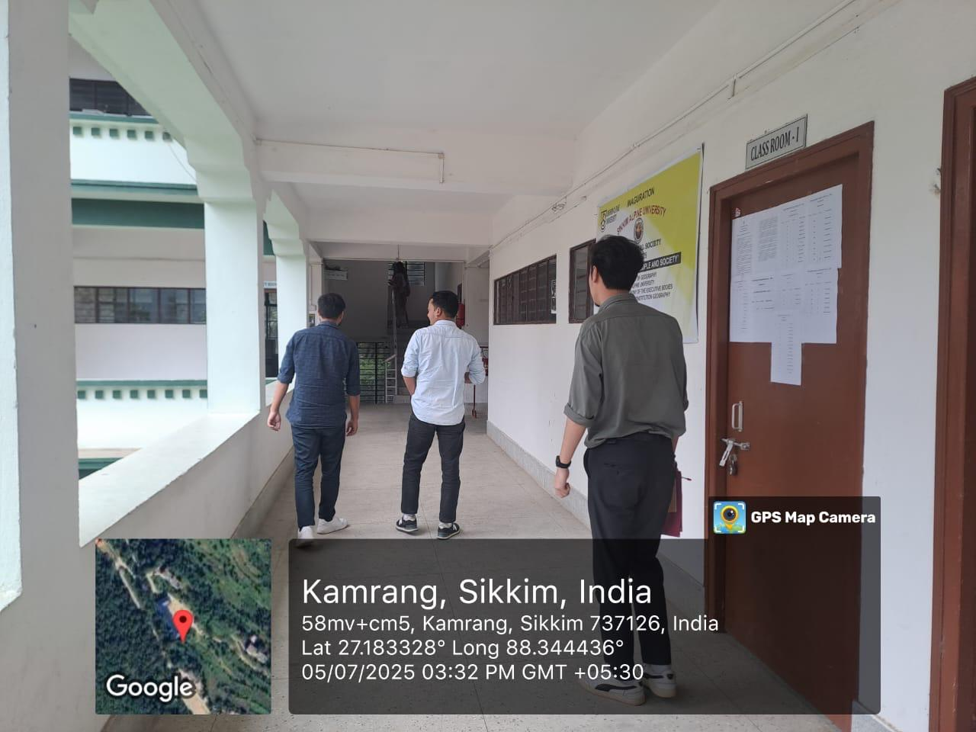
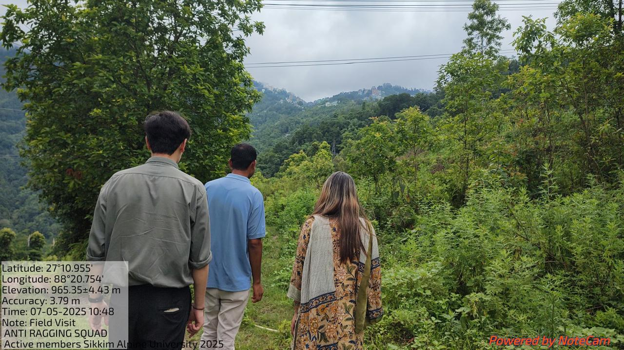

Conclusion:
The Anti-Ragging Squad’s visit was successful in reaffirming the university’s commitment to a ragging-free campus. The positive response from students and the absence of any violations indicate that the anti-ragging mechanisms in place are effective and should be continued in the future.

Report on Anti-Ragging Week Celebration
Organized by: Anti-Ragging Cell, Sikkim Alpine University
Date: 12th to 18th August 2025
Venue: Sikkim Alpine University, Namchi, 737126

Sikkim Alpine University observed Anti-Ragging Week from 12th to 18th August 2025, demonstrating its commitment to creating a safe and inclusive campus environment. The week featured various activities aimed at raising awareness about the dangers of ragging and promoting a culture of respect and safety among students. A key highlight of the celebration was the creation of a UGC-compliant "Shelfie Stand," along with active student participation in producing content for Instagram Threads and posts as part of the anti-ragging campaign.
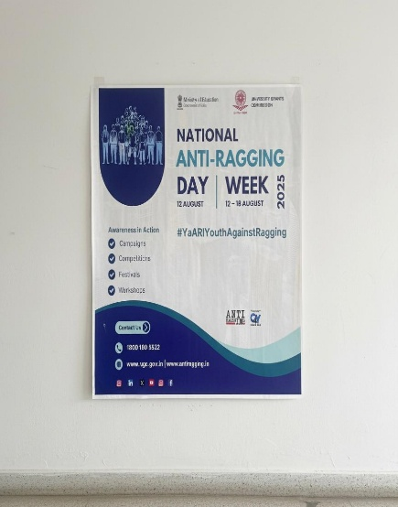
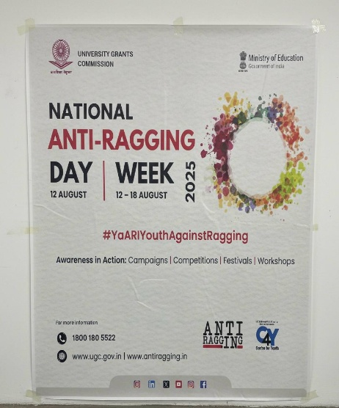

Activities Conducted

1. Shelfie Stand Design
As per the guidelines provided by the University Grants Commission (UGC), a "Shelfie Stand" was designed and set up on campus. The stand served as a focal point for students to take photographs with anti-ragging messages and slogans. The design was carefully crafted to be both visually appealing and informative, attracting students to engage with the anti-ragging campaign. The Shelfie Stand became a popular spot for students to express their support for a ragging-free campus and share their photos on social media, amplifying the message beyond the university.

2. Instagram Threads and Posts
Throughout the week, students actively participated in creating and sharing content on Instagram, using Threads and posts to spread awareness about the anti-ragging campaign. The students collaborated to produce impactful messages, that highlighted the university's anti-ragging policies, the consequences of ragging, and the importance of standing up against such practices.
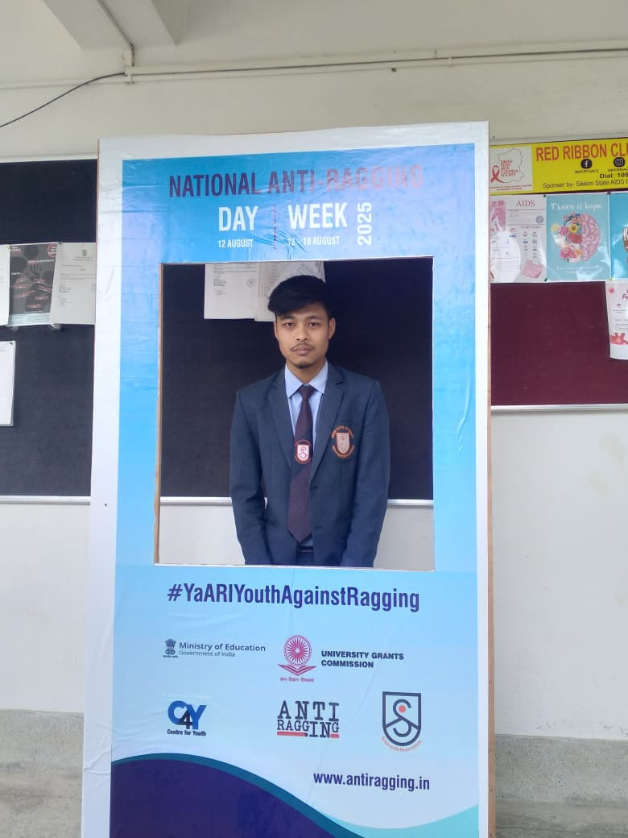
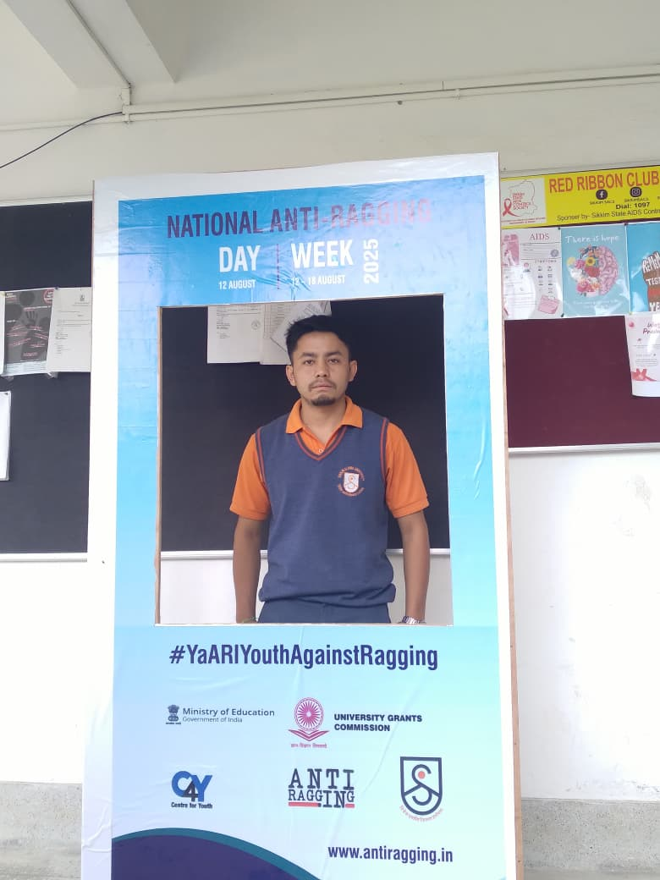
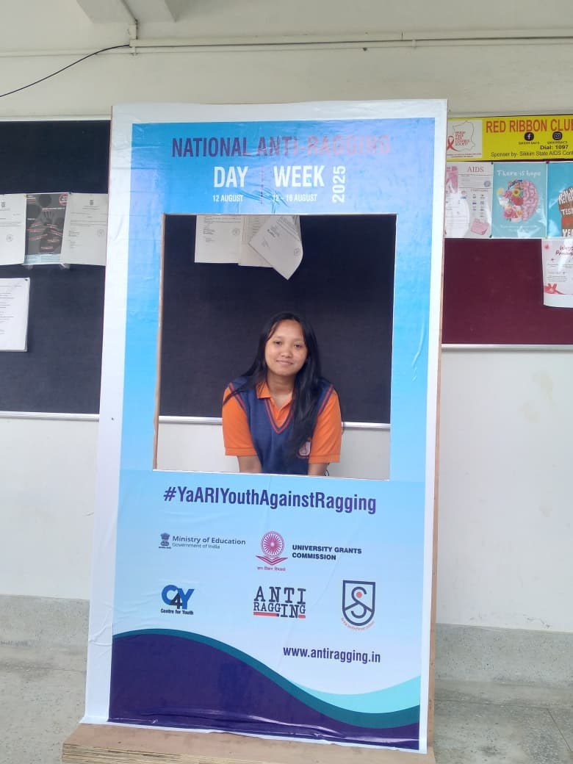
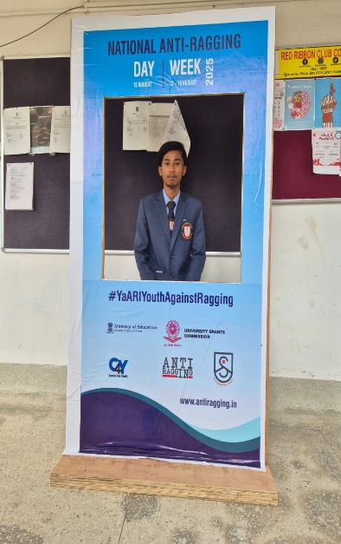
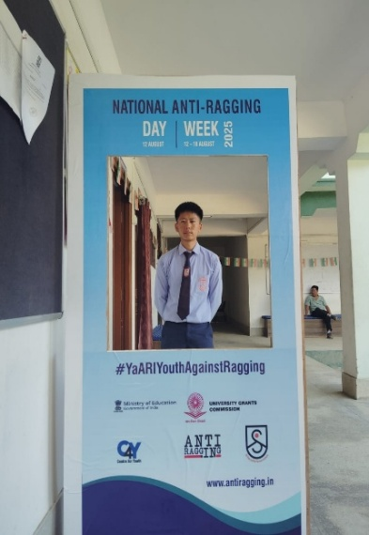
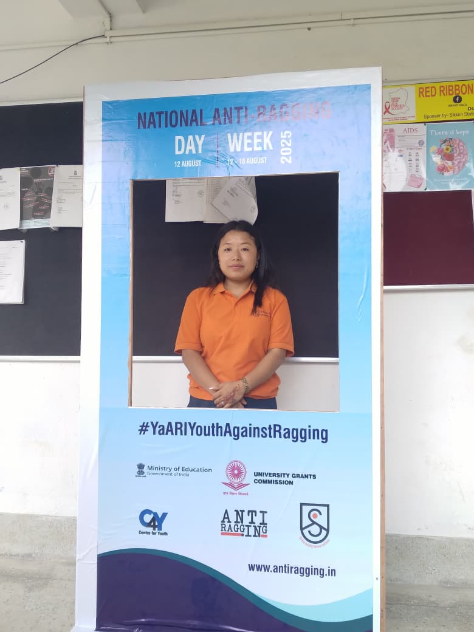
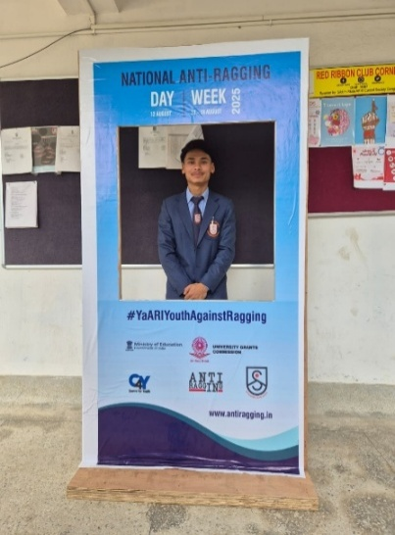
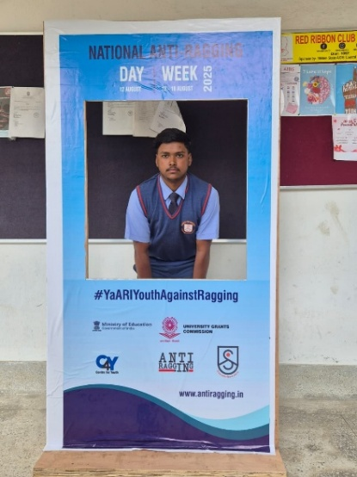
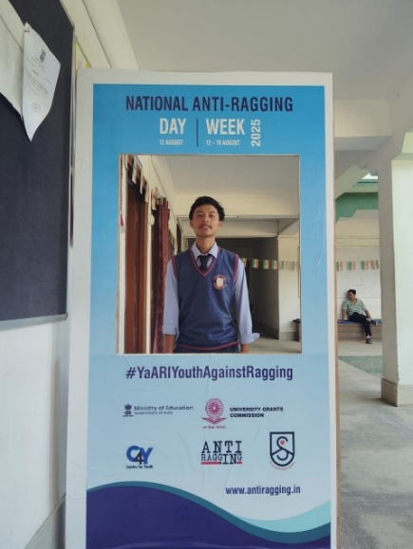
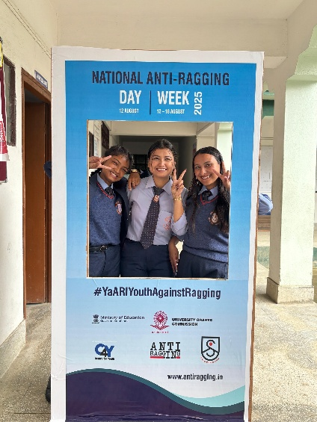
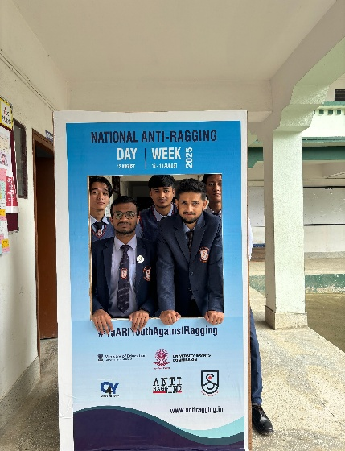
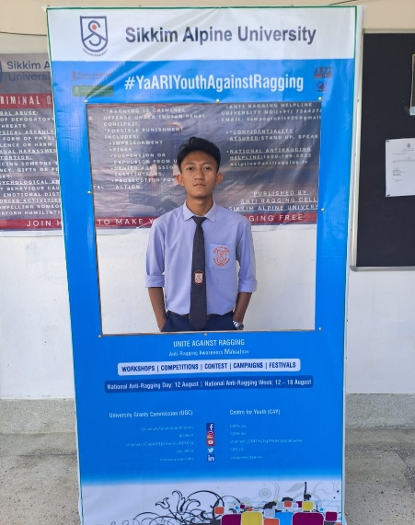

3. Interactive Sessions and Discussions
Alongside the creative activities, the university hosted interactive sessions and discussions focused on the issue of ragging. These were led by faculty members, senior students, and representatives from the Anti-Ragging Cell, who shared valuable insights into the psychological and legal aspects of ragging. Students were invited to ask questions, share their perspectives, and explore ways to contribute to a ragging-free campus. These sessions facilitated open dialogue and underscored the university's dedication to student safety and well-being.
The Anti-Ragging Week celebration was highly successful, drawing enthusiastic participation from both students and staff. The Shelfie Stand and social media campaign effectively captured the students' attention, generating significant interest in the importance of preventing ragging. These activities not only heightened awareness but also empowered students to actively contribute to a safe and respectful campus environment. The digital outreach through Instagram Threads and posts further extended the anti-ragging message to a broad audience, reaching both within and beyond the university community.

4. Conclusion
The observance of Anti-Ragging Week at Sikkim Alpine University from 12th to 18th August 2025 served as a powerful reminder of the institution’s dedication to upholding student welfare and well-being. Through engaging activities, awareness drives, and creative digital campaigns, the university successfully fostered a sense of responsibility, empathy, and unity among students.
By promoting a ragging-free culture and encouraging open dialogue, the university continues to ensure that every student feels safe, respected, and valued within the academic community. These collective efforts reflect the university’s ongoing commitment to protecting the rights, dignity, and holistic welfare of its students, while nurturing a campus environment built on trust, inclusivity, and mutual care.

